1.12 Master Comment Maintenance
We comment here all necessary logistic/sales information about a proper client.

Please, translate line by line into Dutch that your warehousmen can see on each PDL and understand how to handle with all clients.

We usually enter here some short comments also from sales point view.
E.g. when is pallet shipping day, what kind of transport customer prefers to use, contacts, where to send OC, special sales agreements or another important information that also your sales collegues know what to do with each customer when substituting you.
This comment is then visible in 7.1.1 on the first screen when entering sales order.

Reference: Sold to Party number
Language: US
Type: zk
+ Enter (to confirm your new comments)
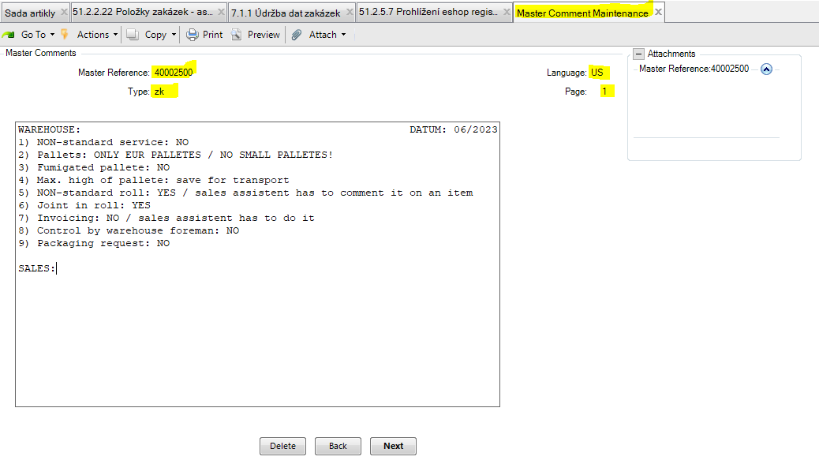
Kindly note that there is limited space on each page. If you need another page, just mark Page = 2.
WE WILL MAINTAIN LIKE THI ALL CLIENTS – SALES ORDER BY SALES ORDER, CLIENT BY CLIENT.

